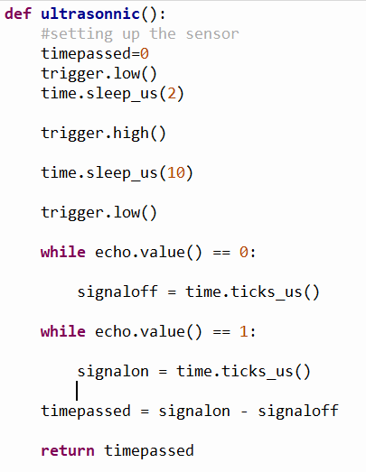

6

5

4

3

2

1

1. **Send Trigger Pulse (Start of Measurement):** The `trig_pin` is briefly pulsed to send a 10-microsecond trigger signal to the HC-SR04 sensor. This triggers the emission of an ultrasonic pulse.

2. **Wait for Echo Pin to Go High (Ultrasonic Pulse Emitted):** The code enters a loop and waits for the `echo_pin` to go high. This transition from low to high indicates that the ultrasonic pulse has been emitted by the sensor and is traveling through the air.

3. **Record Start Time (Pulse Start):** Once the `echo_pin` goes high, the current time in microseconds (`pulse_start`) is recorded using `time.ticks_us()`. This timestamp marks the moment when the ultrasonic pulse was emitted by the sensor.

4. **Wait for Echo Pin to Go Low (Pulse Reflection Detected):** The code enters another loop and waits for the `echo_pin` to go low again. This transition from high to low indicates that the ultrasonic pulse has been reflected off an object and detected by the sensor.

5. **Record End Time (Pulse End):** Once the `echo_pin` goes low, the current time in microseconds (`pulse_end`) is recorded using `time.ticks_us()`. This timestamp marks the moment when the reflected ultrasonic pulse was detected by the sensor.

6. **Calculate Pulse Duration and Distance:** The duration of the ultrasonic pulse's round trip is calculated by subtracting `pulse_start` from `pulse_end`. This duration is then used to calculate the distance to the object using the speed of sound.

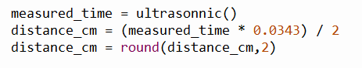

7

7. **Calculate Distance to Object:** The calculated pulse duration is used to calculate the distance to the object based on the speed of sound in the air. The distance calculation considers the time it took for the pulse to travel to the object and back.

8. **Repeat:** The measurement process is repeated in a loop to continuously measure and display the distance to the object.

**Once the measured time is known (in microseconds) we use this formula to calculate the distance**

**Speed of sound in cm per seconds = 34300 cm / seconds**

**Distance = Speed * Time (measured distance)**

**For example – measure time is 616us, we convert it to seconds**

**616 us = 616/1000000 seconds**

**Distance = 34300 * 616 / 1000000**

We then divide this Distance by 2 which is the actual distance of the object from the sensor.

The flight time measured by the HC-SR04 ultrasonic sensor can be converted to centimeters using the formula:

Distance (in cm) = (Speed of Sound (in cm/μs) × Flight Time (in μs)) / 2

Here's a breakdown of the components of the formula and how the conversion works:

1. **Speed of Sound (in air):** The speed of sound varies depending on factors like temperature, humidity, and air pressure. In dry air at around 20°C (68°F), the speed of sound is approximately 343 meters per second (m/s), or about 0.0343 centimeters per microsecond (cm/μs).
2. **Flight Time:** The flight time is the time it takes for the ultrasonic pulse to travel from the sensor to the object and back. It's measured in microseconds (μs) using the timestamps recorded by the code.
3. **Division by 2:** The division by 2 is necessary because the flight time represents the time for the pulse to travel to the object and then back to the sensor. To get the one-way distance to the object, you need to halve the total time.

By plugging in the values and performing the calculation, you can convert the flight time to the distance in centimeters. Here's the formula applied to calculate the distance in centimeters:

Distance (in cm) = (Speed of Sound (in cm/μs) × Flight Time (in μs)) / 2

Let's say you measured a flight time of 1000 microseconds:

Distance = (0.0343 cm/μs × 1000 μs) / 2 = 17.15 cm

So, based on the measured flight time, the calculated distance to the object would be approximately 17.15 centimeters.

Keep in mind that this formula assumes constant and uniform conditions, particularly a consistent speed of sound. Variations in temperature, humidity, and air pressure can affect the accuracy of the distance measurement. Additionally, the HC-SR04 has a limited accuracy range, so the calculated distance might not be entirely precise, especially at very close or very far distances.